Network Attack Classification over OpenFlow

Nidhi Madappa Prachi Bhole Sunil Venkatraman Supriya Singh
Dept. of Computer Science
University of Southern California
Los Angeles, USA

Abstract— Anomaly-based intrusion detection systems are usually criticized because they lack a classification of attack, thus security teams have to manually inspect any raised alert to classify it. Additionally, it is hard for systems to detect distributed attacks due to the similarities between the normal traffic and the malicious traffic. This paper presents a way to detect distributed attacks and classify them using openflow, in which traffic details can be extracted with a very low overhead. Naïve Bayes statistical classifier is used for fast attack classification based on the attack patterns.
Index Terms—network security attack, openflow, naïve Bayes classifier

INTRODUCTION

RELATED WORK
.

BACKGROUND

POX/OpenFlow Overview

OpenFlow [7] is an open standard that enables researchers to run experimental protocols in the campus networks we use every day. In a classical router or switch, the fast packet forwarding (data path) and the high level routing decisions (control path) occur on the same device. An OpenFlow Switch separates these two functions. The data path portion still resides on the switch, while high-level routing decisions are moved to a separate controller, typically a standard server. The OpenFlow Switch and Controller communicate via the OpenFlow protocol, which defines messages, such as packet-received, send-packet-out, modify-forwarding-table, and get-stats.

The data path of an OpenFlow Switch presents a clean flow table abstraction; each flow table entry contains a set of packet fields to match, and an action (such as send-out-port, modify-field, or drop). When an OpenFlow Switch receives a packet it has never seen before, for which it has no matching flow entries, it sends this packet to the controller. The controller then makes a decision on how to handle this packet. It can drop the packet, or it can add a flow entry directing the switch on how to forward similar packets in the future.

Apart from the source and destination addresses and ports and the protocol, per-flow statistics are a compound of three values: [7]
1) Received packets which count the number of packets matching the flow they belong to;
2) Received bytes which store the amount of bytes received by the current flow; and
3) Duration of the time interval a flow spends in the flow table of the switch being analyzed.
If a flow entry of a given switch does not receive any new packets, then it is automatically deleted from the switch’s Flow Table by the network operating system. POX is a platform for the rapid development and prototyping of network control software using Python, or in other words it is a framework for writing an OpenFlow controller.

For our implementation, we have used Open vSwitch[6], which is a production quality open source software switch designed to be used as a vswitch in virtualized server environments. A vswitch forwards traffic between different VMs on the same physical host and also forwards traffic between VMs and the physical network. Open vSwitch supports standard management interfaces (e.g. sFlow, NetFlow, RSPAN, CLI), and is open to programmatic extension and control using OpenFlow and the OVSDB management protocol.

Network Attack Patterns
In this section, we provide some examples of attack patterns. DoS/DDoS attacks cause a waste of the resources in the host or networks, and make services work improperly. There are two principal classes of DoS/DDoS, logic and flooding attacks [8].

Logic attacks exploit existing software flaws to cause a malfunction in the system. For instance, a Land attack [9] may crash the system by sending packets with the source host and port the same as the destination host and port.

Flooding attacks transmit many spurious packets to the target system, and waste CPU, memory, and network resources. In case of TCP SYN flood [10], the victim receives packets that exceed buffer of the data structure limit and cripple its service. Also, ICMP, TCP, and UDP flooding attacks [12] overwhelm bandwidth by sending useless traffic to the victim. Some attacks, such as Smurf [11] and Fraggle [13], amplify traffic by using reflecting services of the third party.

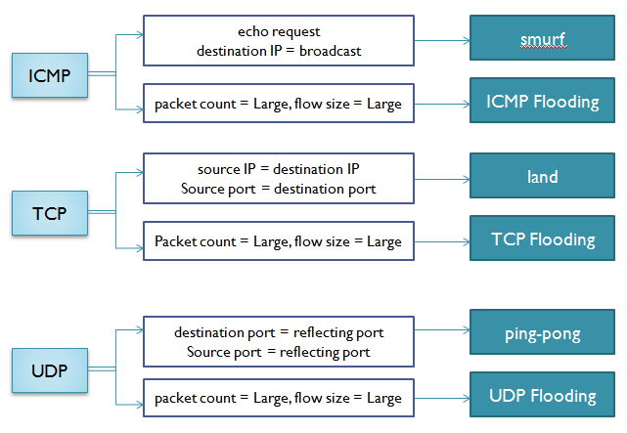
Figure 1 Attack traffic patterns

Each of these attacks has a peculiar pattern as depicted in Figure 1. [1] For example, if the transport protocol is ICMP and its type is echo request and destination is broadcast, then this flow is determined to be a smurf attack. The reason is that the attack mainly sends spoofed source IP packets to the destinations of broadcast. In the case of a TCP transport protocol; this part certifies if the pair of source IP, source port is identical with the pair of destination IP, destination port for the purpose of detecting a Land attack.

The Smurf and Fraggle attacks force traffic gathered to the victim by using a third party. This type of attack creates as many flows as the number of hosts of the third party used in attacking. Consequently, the total bandwidth and total packet count increase. These attacks use third party and amplify traffic that is mainly destined to a broadcast address. Two attacks, Smurf and Fraggle, differ in the used protocol. Smurf makes use of ICMP and Fraggle uses UDP.

In addition to the attacks described above, general ICMP, UDP, TCP flooding attacks have dynamic traffic patterns depending on how many packets and hosts are used for an attack. However, most attacks create a large total bandwidth and high total packet count. Additionally, such traffic has a small deviation in the packet and flow size of each flow.

Naïve Bayes Classifier
Naïve Bayesian Classifier is a statistical classifier based on Bayes Theorem that predicts class membership probabilities. It has a performance comparable to decision trees and selected neural network classifiers.

This Bayesian classifier is termed as naive because it relies on two important simplifying assumptions. In particular, it assumes that the predictive attributes are conditionally independent given the class, and it posits that no hidden or latent attributes influence the predictive process. Thus, when depicted graphically, a naive Bayesian classifier has the form shown in Figure 1, in which all arcs are directed from the class attribute to the observable, predictive attributes. [3]
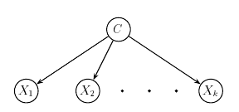
Figure 2 A naïve Bayesian classifier depicted as a Bayesian network in which predictive attributes (X₁, X₂….X_{k}) are conditionally independent given the class attribute (C)
These assumptions support very efficient algorithms for both classification and learning. [4] To see this, let C be the random variable denoting the class of an instance and let X be a vector of random variables denoting the observed attribute values. Further, let c represent a particular class label, and let x represent a particular observed attribute value vector. Given a test case x to classify, one simply uses Bayes' rule to compute the probability of each class given the vector of observed values for the predictive attributes,

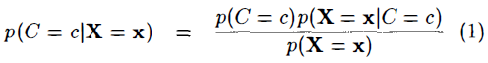

and then predicts the most probable class. Here X = x represents the event that X₁ = x₁ /\ X₂ = x₂ /\ … X_{k} = x_{k}. Because the event is simply a conjunction of attribute value assignments, and because these attributes are assumed to be conditionally independent, one obtains

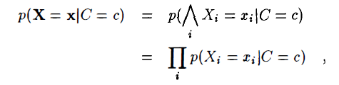

which is simple to compute for test cases and to estimate from training data. Generally one does not directly estimate the distribution in the denominator of Equation 1, as it is just a normalizing factor; instead one ignores the denominator and then normalizes so that the sum of p(C = c|X = x) over all classes is one.

Naïve Bayes treats discrete and numeric attributes somewhat differently.[4] For each discrete attribute, p(X = x|C = c) is modeled by a single real number between 0 and 1 which represents the probability that the attribute X will take on the particular value x when the class is c. In contrast, each numeric attribute is modeled by some continuous probability distribution over the range of that attribute's values. A common assumption, not intrinsic to the naive Bayesian approach but often made nevertheless, is that, within each class, the values of numeric attributes are normally distributed.

For example, suppose the training data contain a continuous attribute, . We first segment the data by the class, and then compute the mean and variance of in each class. Let be the mean of the values in associated with class c, and let be the variance of the values in associated with class c. Then, the probability of some value given a class, , can be computed by plugging into the equation for a Normal distribution parameterized by and . That is,
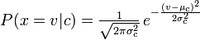

For discrete values, m-estimates are made. [5]

ATTACK CLASSIFICATION METHOD OVER OPENFLOW
For the attack classification, we first select the traffic features to classify the attacks on and then build the naïve Bayes classifier based on these features. Then we simulate different attacks using SEER tool [14] on DETER and gather the flow table entries into a training set that is used for training the classifier.

Traffic Feature Selection

We have employed the 6 features proposed in [2]–APf, ABf, ADf, PPf, GSf, and GDP–to compose the 6-tuple utilized in our method. These features can be constructed from the flow table as shown in Figure 3.

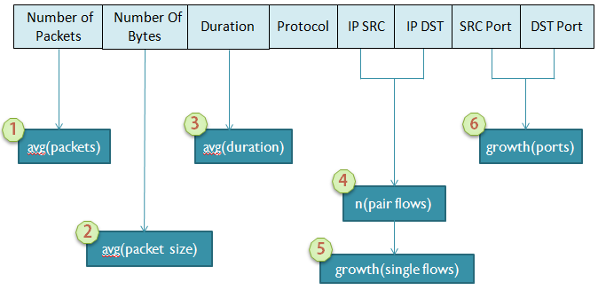
Figure 3 Selection of traffic features for attack classification

Experiment Setup

We setup the Open Vswitch with 4 nodes for our experiment as shown in Figure 4, although more nodes or subnets can be added. This switch will be controlled by POX, where the classifier will also run. One of the nodes acts as the target for the distributed denial of service attacks that would be generated by the SEER tool.

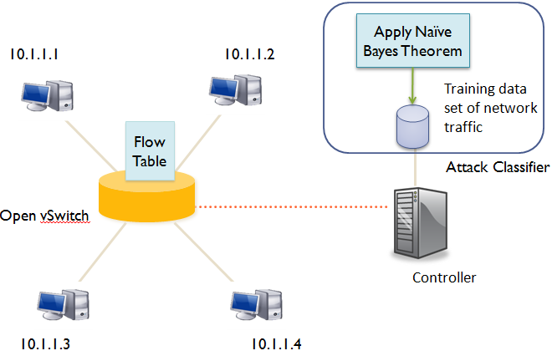
Figure 4 Experiment setup for attack classification

Experiment Procedure

- Normal as well as attack traffic is generated using the SEER tool [14]. The different attacks simulated in our experiment were Smurf, Fraggle, TCP SYN/FIN flood, TCP SYN Flood, ICMP flood and UDP flood.
- The flow table entries generated from Step 1 are collected in a CSV file.
- The Bayes statistical classifier is trained using this CSV file to recognize these attacks based on their varying traffic features and attack patterns.
- Real-time attack traffic is generated.
- POX supplies the flow table entries to the classifier.
- The classifier takes a median of these entries and classifies the attack traffic.
- If a distributed attack is detected, the individual entries in the flow table are classified as offending or normal.
- The offending flow table entries are removed from the flow table.

RESULTS

CONCLUSION

References

- Myung-Sup Kim, un-Jeong Kang, Seong-Cheol Hong, Seung-Hwa Chung, James W. Hong, “A Flow-based Method for Abnormal Network Traffic Detection,” Network Operations and Management Symposium, Seoul, S. Korea, April 2004.
- Rodrigo Braga, Edjard Mota, Alexandre Passito, “Lightweight DDoS Flooding Attack Detection Using NOX/OpenFlow” Proceedings of the 2010 IEEE 35th Conference on Local Computer Networks, p.408-415, October 10-14, 2010
- Buntine, W.L. "Operations for learning with graphical models", Journal of Artificial Intelligence Research 2, 1994, 159 - 225
- George H. John, Pat Langley, “Estimating Continuous Distributions in Bayesian Classifiers” In Proceedings of the Eleventh Conference on Uncertainty in Artificial Intelligence, 1995
- F. Keller, “Naive Bayes Classifiers”, Connectionist and Statistical Language Processing, Course at Universit¨at des Saarlandes, Germany, 2002: http://homepages.inf.ed.ac.uk/keller/teaching/connectionism/lecture10_4up.pdf. Accessed January 2004.
- http://openvswitch.org/
- www.openflow.org
- D. Moore, G. M. Voelker, and S. Savage, “Inferring Internet Denial-of-Service Activity,” Proc. of USENIX Security Symposium, Washington D.C, Aug 2001.
- Common Vulnerabilities and Exposures (CVE), “Land (CVE-1999-0016),” http://www.cve.mitre.org/cgi-bin/cvename.cgi?name=CVE-1999-0016.
- Common Vulnerabilities and Exposures (CVE), “SYN flood (CVE-1999-0116),” http://www.cve.mitre.org/cgi-bin/cvename.cgi?name=CVE-1999-0116.
- Common Vulnerabilities and Exposures (CVE), “Smurf (CVE-1999-0513),” http://www.cve.mitre.org/cgi-bin/cvename.cgi?name=CVE-1999-0513.
- Common Vulnerabilities and Exposures (CVE), “UDP packet storm (CVE-1999-0103),” http://www.cve.mitre.org/cgi-bin/cvename.cgi?name=CVE-1999-0103.
- Common Vulnerabilities and Exposures (CVE), “Fraggle (CVE-1999-0514),”http://www.cve.mitre.org/cgi-bin/cvename.cgi?name=CVE-1999-0514.
- http://seer.deterlab.net/trac

